Invasion Card Spotlight: Urza's Rage
Jeff Donais

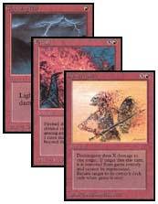
The original direct damage spells

History of Direct Damage
Red direct damage has been a basic theme of Magic: The Gathering since the Alpha edition, with cards like Lightning Bolt, Fireball and Disintegrate. We've seen dozens of interesting direct damage spells since then, such as Hammer of Bogardan, Incinerate, Fireblast, Kaervek's Torch and Seal of Fire. Each of these cards had a specific situation where they excelled and situations where they were less useful.
Some of the direct damage proved to be too powerful and unbalanced the game environment, with the potential to end the game too quickly. Fireblast was the most obvious of these spells and dominated the Standard environment whenever it was present. Lightning Bolt was also very undercosted (three damage for one mana) and was eventually replaced in the Magic base set with Shock, which was more appropriately costed (two damage for one mana).
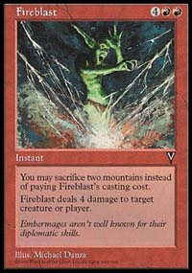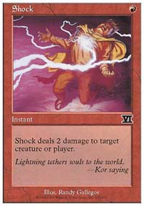
Fireblast was overpowered, Shock is well balanced
The current strategy of Magic R&D is to create balanced direct damage spells that trade mana cost for effectiveness. For a spell with lots of fancy advantages, you will pay extra mana. Arc Lightning does three damage, but it allows the player of the spell to distribute the damage to any targets, which provides flexibility. Arc Lighting costs three mana because of this extra feature. Rolling Thunder cost more mana than Fireball because it had the same advantage as Arc Lighting - it could distribute damage exactly how the player chose. New spells that are created by R&D will sometimes trade damage and mana cost for flexibility and special features.
No Magic expansion would be complete without some variation of the red direct damage spell and Invasion is no exception. Invasion contains several direct damage spells. One of the most powerful and interesting is Urza's Rage.
Urza's Rage
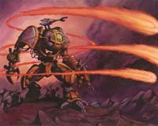
Instant | Rare
Kicker (You may pay an additional as you play this spell.)
Urza's Rage can't be countered by spells or abilities.
Urza's Rage deals 3 damage to target creature or player. If you paid the kicker cost, instead Urza's Rage deals 10 damage to that creature or player and the damage can't be prevented.
Illus. Matthew D. Wilson
178/350

Urza's Rage Card Theme
The art of Urza's Rage portrays the Phyrexian attack. Invasion is all about the killer machines of Phyrexia attacking Dominaria, and Urza gathering troops to fight them off. The title "Urza's Rage" probably refers to the fact that he's a little angry with the Phyrexians and will soon channel his rage to destroy the Phyrexian machine portrayed in the art of the card. That would fit perfectly with the abilities of the card. The art is quite good, as is the Invasion art in general. The Magic artists have done a great job throughout the Invasion set.

Urza's Rage Strategy
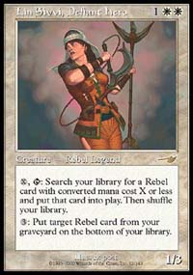
Urza's Rage can deal with three toughness creatures, unlike Seal of Fire or Shock.
For 2, Urza's Rage is an instant that deals three damage to any target and cannot be countered. If you use the kicker and pay a total of ten colorless and two red mana when you play the spell, you get ten damage and the spell may not be countered or prevented.
When the kicker cost is paid, Urza's Rage deals brutal damage and is almost impossible to stop. This gives the card excellent flexibility in Limited environments where it can be used for early creature removal or as a late game finisher card. Expect Urza's Rage to be a potential first pick during booster and Rochester draft. It's a good card to include in any sealed deck that has red as a main or secondary color. There is only one red mana in the mana requirement for early use (2) and with the kicker during the late game, the two red mana requirement should be easy enough to satisfy (10).
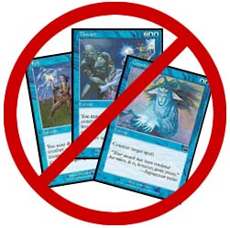
These spells cannot stop Urza's Rage
Dave DeLaney says (from the Invasion FAQ):
Note that this is different from Obliterate: Obliterate can't be countered -period-. This can't be countered -by spells or abilities-. ("What's left?", you ask? The rules of the game can counter Urza's Rage: specifically, if its -target- is illegal by the time it would resolve, it gets countered and has no effect.) The spell deals either 3 or 10 damage, not 13. If you paid the kicker, then any "prevent some/all of the next damage" shields affecting the target won't prevent any of UR's damage (and won't be used up trying to do so - they'll just wait until the next damage comes along this turn).
One of the advantages that Urza's Rage has over cards like Seal of Fire and Shock is dealing three damage instead of two damage. Many of the popular creatures in the Mercadian Masques and Invasion Standard environment will have three toughness. Creatures like Lin Sivvi, Drake Hatchling, Chimeric Idol, Mageta, Silt Crawler and many tournament-level Invasion creatures will not die to Shock or Seal of Fire, but can be dealt with using Urza's Rage.
Three mana for three damage is not the best deal in the world, but the extra abilities are very intriguing. Having a spell that cannot be countered is an incredible advantage against control decks that rely on Counterspell style cards to protect their creatures or themselves.
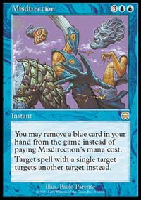
The best way to deal with Urza's Rage is to misdirect it.
The impact of Urza's Rage on control decks should be significant. An aggressive deck can probably deal ten damage to an opponent playing a control style deck before the opponent manages to take control of the game. All the aggressive player would need to do is wait until they build up to twelve mana and play Urza's Rage with kicker. There is very little that a control player can do against a spell that deals ten damage and cannot be countered or prevented.
It should be noted that the spell Misdirection can deal with Urza's Rage because Misdirection redirects the target instead of countering the spell. When Urza's Rage becomes popular, Misdirection should become a popular way for control deck players to deal with the card.
Expect Urza's Rage to be one of the most popular Invasion cards among red players. If you want to see one for yourself, check out an Invasion prerelease tournament on September 23, where you can get a bunch of Invasion cards and a special rare foil-stamped Invasion prerelease premium card. For a schedule, click here.
On Monday: Zvi Mowshowitz on Sterling Grove's two abilities.

